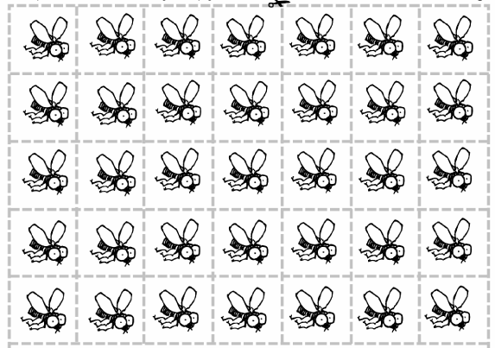

Feed Me – Frog Math Games

Cut out (or have students cut out) the flies. Provide each student with a plate to represent their own “lily pad.”

- Use with 1.OA.3-6 Frog flipchart to help with the think, pair, share process. Lily pads for the floor numbered 10-20 should also be made to supplement the flipchart.